Damping off (Rhizoctonia solani) life cycle notes:

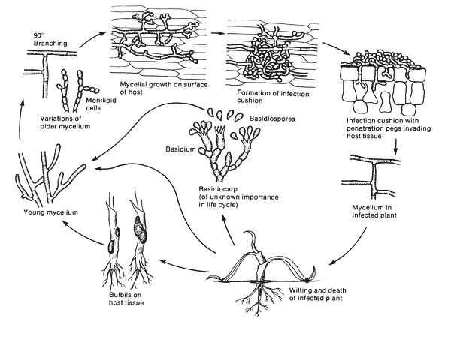
From APS…https://www.apsnet.org/edcenter/disandpath/fungalbasidio/pdlessons/Pages/Rhizoctonia.aspx
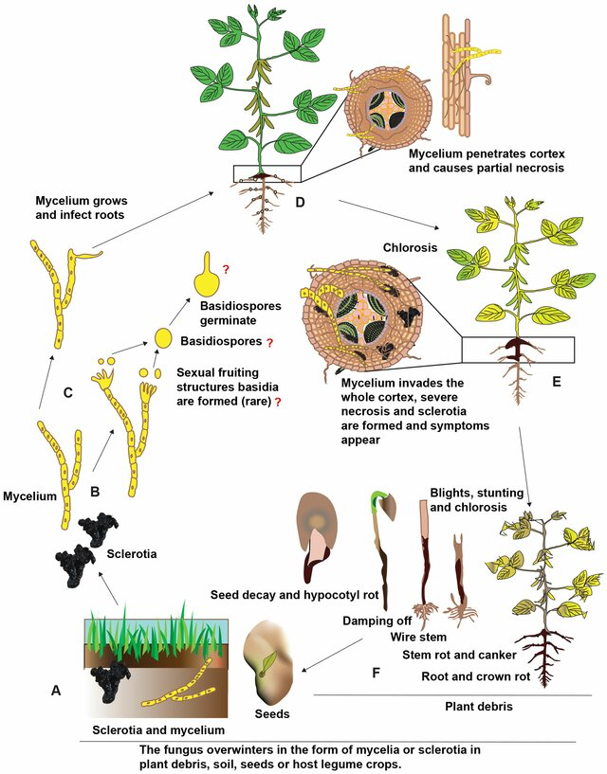
Akber, Muhammad & Mubeen, Mustansar & Sohail, Muhammad & Khan, Sher & Solanki, Manoj & Khalid, Rida & Abbas, Aqleem & Kumar, Dr.D.Praveen & Zhou, Lei. (2023). Global distribution, traditional and modern detection, diagnostic, and management approaches of Rhizoctonia solani associated with legume crops. Frontiers in Microbiology. 13. 10.3389/fmicb.2022.1091288.

The life cycle of Rhizoctonia solani is as follows:
- Overwinter: Mycelium and sclerotia survive in soil, plant debris, or host plants.
- Hyphae: Young hyphae gradually develop into older mycelium.
- Colonization: The older mycelium colonizes the plant's surface and produces infection cushions.
- Penetration: The fungus penetrates the plant through natural openings or wounds, or by forming infection pegs.
- Nutrient uptake: The fungus takes up nutrients from the plant to continue growing and developing.
- Necrosis: The fungus kills plant cells, causing necrosis and sclerotia to form in and around the infected tissue.
- New inoculum: The fungus produces new inoculum, and the life cycle repeats when fresh plant material becomes available

Structures:
- Branching mycelium
- Infection cushion
- Basidia
- Basidiospores
- Microsclerotia
- Sclerotia
- Penetration peg (appressorium)
- Plant wilt
- Mycelium invading vascular tissue

Rhizoctonia solani is the asexual name for the basidiomycete fungus with the sexual state (teleomorph) Thanatephorus cucumeris. Anderson 1982 explains that R. solani is not a single species but a group of species (species complex) that has led to difficulties in studying and controlling this pathogen.
The fungus produces haploid basidiospores which germinate and are themselves capable of producing asexual conidia. Rhizoctonia is also capable of forming microsclerotia (Anderson 1982). Rhizoctonia is a facultative pathogen that can survive on dead material. It can also be grown, and sexually mated, in vitro (Carling et al. 1987).

